**Uploading the data (bank marketing train)**

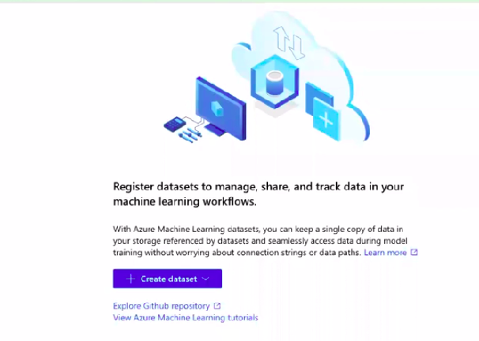

click on create datasets >> local file >> enter basic information

Once that is done, we can see a preview that lets us select the columns needed

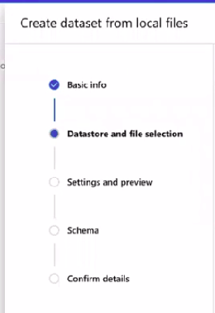

enter all the necessary information from settings and preview select the columns needed

**Choosing ML model:**

Select Automated ML in Author section in left menu

>> create a new automated ml

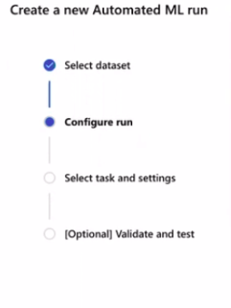

>> select dataset

>> in configure section give an experiment name, target column Y containing yes and no labels that we are predicting

>> select the compute instance (Note: the created compute instance must be up and running)

>> select task and settings (select classification)

>> click on finish

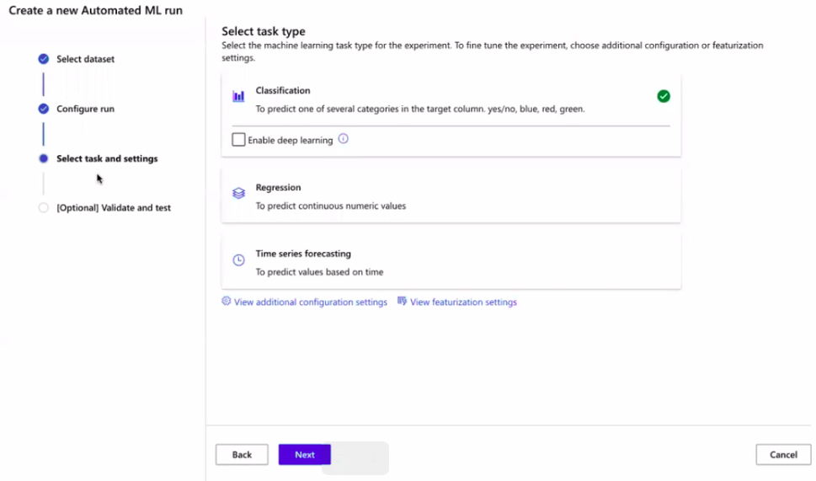

Select the model with higher score 95 percent accuracy

For deployment

Here it takes time to create a models with best score in our case accuracy

**Deployment of model:**

Go in experiment section

>> select the displayed model that need to be deployed

click on designer to create a deployment

>> select compute instance

>> drag and drop the data

>> select all columns (exclude those that are not needed)

>> clean missing data

>> Select split data to split the data

>>Select Train Model and give the name of the target column Y

>> Use random Forest to train the model

>> Connect split data to Select score Model

>> select SUBMIT on top right corner

**Creating pipeline:**

click on the create inference pipeline

>> click on real time inference pipeline

>> click submit

>> click on deploy once

